ALZHEIMER'S DISEASE
A Comprehensive Neuroscience Atlas
Understanding the Disease from Brain Anatomy
to Molecular Mechanisms and Clinical Diagnosis
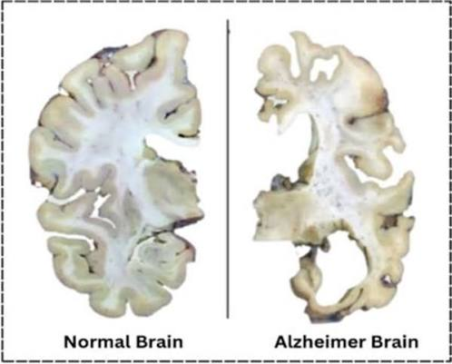

Author : Shreya Shankar

Independent Neuroscience Project

ABOUT THIS PROJECT

Introduction
Alzheimer's disease is the most common cause of dementia and one of the fastest-growing neurological disorders worldwide. It is a progressive neurodegenerative disease characterized by the gradual loss of memory, cognitive abilities, and independent functioning. As populations age, the global burden of Alzheimer's disease continues to increase, making it a major public health challenge.
Advances in neuroscience have shown that the pathological changes responsible for Alzheimer's disease begin many years before clinical symptoms appear. Early detection, accurate diagnosis, and timely intervention are therefore essential for improving patient care and developing effective disease-modifying therapies.
This project presents a comprehensive overview of Alzheimer's disease, integrating knowledge from neuroanatomy, molecular neuroscience, neuropathology, clinical medicine, and current research. Rather than focusing on a single aspect of the disease, it provides a structured journey from the healthy brain to the biological mechanisms underlying neurodegeneration, followed by diagnostic approaches, biomarkers, treatment strategies, and future directions in Alzheimer's research.

Why Alzheimer's Disease Matters
Alzheimer's disease affects millions of individuals and families across the world and is responsible for approximately 60–70% of all dementia cases. The disease not only impacts memory and cognitive function but also places significant emotional, social, and economic burdens on patients, caregivers, healthcare systems, and society.
Understanding the mechanisms underlying Alzheimer's disease is essential for improving early diagnosis, developing more effective treatments, and ultimately reducing the global burden of neurodegenerative disorders.

Purpose of This Project
The purpose of this project is to provide an evidence-based educational resource that explains Alzheimer's disease from multiple scientific perspectives. By combining information on brain anatomy, disease mechanisms, biomarkers, neuroimaging, and current therapeutic approaches, this project aims to present a clear and comprehensive understanding of the disorder.

Who Can Use This Project?
This project is intended for:
- Undergraduate and postgraduate students studying neuroscience, biology, medicine, psychology, or related disciplines.
- Educators seeking a structured teaching resource on Alzheimer's disease.
- Researchers interested in the biological basis of neurodegeneration.
- Healthcare professionals looking for a concise overview of current diagnostic and therapeutic approaches.
- Anyone interested in understanding the science behind Alzheimer's disease.

Learning Objectives
After reading this project, the reader will be able to:
- Understand the normal anatomy and function of the human brain.
- Identify the major brain regions affected by Alzheimer's disease.
- Explain the molecular and cellular mechanisms responsible for neurodegeneration.
- Describe the progression of Alzheimer's disease from early pathological changes to advanced dementia.
- Compare currently available biomarkers used for early diagnosis.
- Interpret the role of neuroimaging techniques such as MRI and PET.
- Evaluate current treatment options and emerging therapeutic strategies.
- Recognize future directions in Alzheimer's disease research.

Project Roadmap
Healthy Brain
│
▼
Brain Anatomy
│
▼
Brain Regions Affected
│
▼
Healthy vs Alzheimer's Brain
│
▼
Disease Mechanism
(Amyloid • Tau • Inflammation)
│
▼
Disease Progression
│
▼
Clinical Manifestations
│
▼
Diagnosis & Neuroimaging
│
▼
Biomarkers (CSF • Blood • PET)
│
▼
Current & Emerging Treatments
│
▼
Future Research Directions

Healthy Brain Anatomy
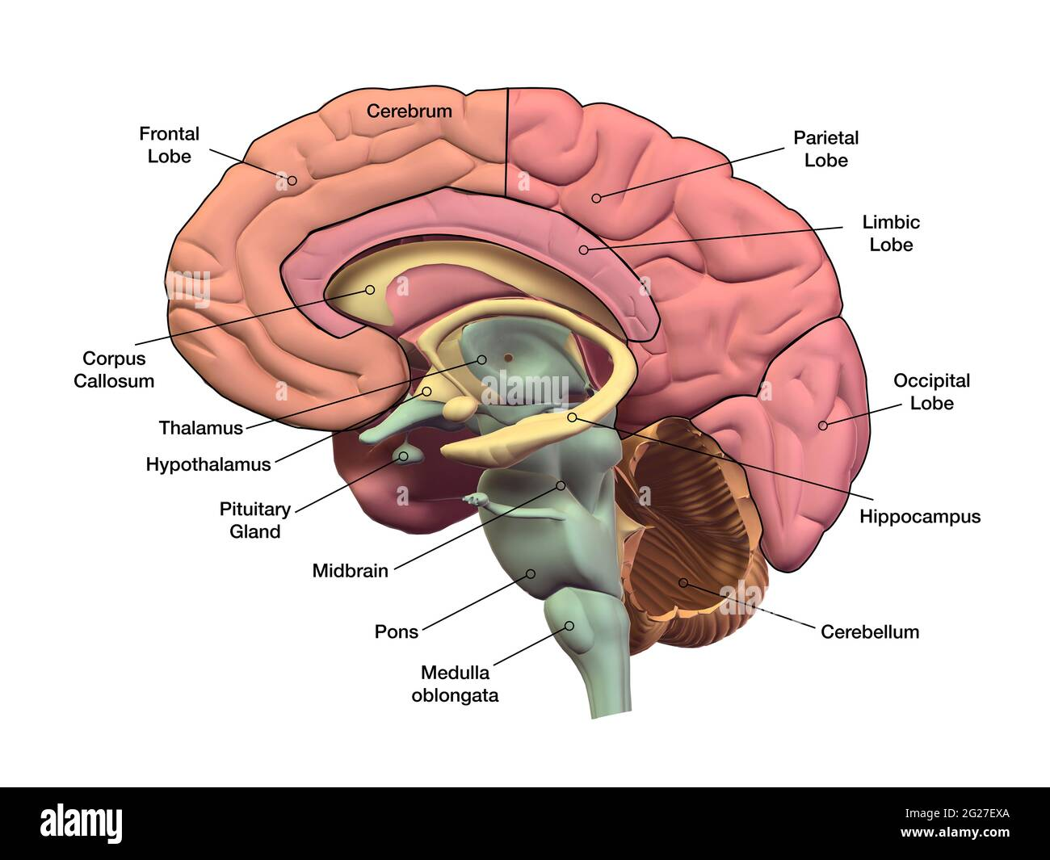

1. Cerebrum

Function
- Largest part of the brain.
- Controls thinking, memory, learning, intelligence, emotions, language, and voluntary movement.
- Processes sensory information.

Alzheimer's Relevance
- Progressive shrinkage (cortical atrophy).
- Responsible for cognitive decline and dementia.

2. Frontal Lobe

Function
- Decision making
- Planning
- Problem solving
- Personality
- Attention
- Voluntary movement
- Speech production (Broca's area)

Alzheimer's Relevance
- Affected during later stages.
- Causes poor judgement, personality changes, impaired planning, and reduced attention.

3. Parietal Lobe

Function
- Processes touch, pain, temperature, and pressure.
- Spatial awareness.
- Hand-eye coordination.
- Reading and writing.

Alzheimer's Relevance
- Degeneration causes difficulty recognizing locations, getting lost, and problems performing everyday tasks.

4. Occipital Lobe

Function
- Primary visual processing center.
- Interprets color, shape, and movement.

Alzheimer's Relevance
- Usually affected in later stages.
- May contribute to visual perception problems.

5. Limbic Lobe

Function
- Emotion
- Motivation
- Learning
- Memory
- Emotional behaviour

Alzheimer's Relevance
- Degeneration contributes to emotional instability, anxiety, depression, and behavioural symptoms.

6. Hippocampus

Function
- Formation of new memories.
- Learning.
- Spatial navigation.

Alzheimer's Relevance
- First major brain region affected.
- Severe hippocampal atrophy causes early memory loss.
- One of the earliest MRI findings.

7. Corpus Callosum

Function
- Connects the left and right cerebral hemispheres.
- Allows communication between both sides of the brain.

Alzheimer's Relevance
- Progressive thinning may impair communication between brain hemispheres.

8. Thalamus

Function
- Relay station for sensory and motor signals.
- Regulates consciousness, alertness, and sleep.

Alzheimer's Relevance
- Secondary involvement may contribute to cognitive dysfunction and altered attention.

9. Hypothalamus

Function
- Maintains homeostasis.
- Controls body temperature.
- Hunger and thirst.
- Sleep-wake cycle.
- Hormone regulation.

Alzheimer's Relevance
- Degeneration may contribute to sleep disturbances, appetite changes, and hormonal imbalance.

10. Pituitary Gland

Function
- Master endocrine gland.
- Releases hormones regulating growth, metabolism, reproduction, and stress responses.

Alzheimer's Relevance
- Not directly affected, but endocrine changes may influence disease progression.

11. Midbrain

Function
- Eye movements.
- Hearing and visual reflexes.
- Motor control.
- Dopaminergic pathways.

Alzheimer's Relevance
- Usually less affected than cortical structures but may contribute to motor and behavioural symptoms in advanced disease.

12. Pons

Function
- Connects cerebrum and cerebellum.
- Regulates breathing.
- Sleep.
- Facial sensation and movement.

Alzheimer's Relevance
- Generally preserved until late stages.

13. Medulla Oblongata

Function
- Controls vital autonomic functions.
- Heart rate.
- Breathing.
- Blood pressure.
- Swallowing.

Alzheimer's Relevance
- Usually affected only in very advanced disease.

14. Cerebellum

Function
- Balance.
- Coordination.
- Fine motor control.
- Motor learning.

Alzheimer's Relevance
- Relatively spared during early Alzheimer's disease but may contribute to gait and balance problems in later stages.

EFFECTED BRAIN REGIONS
Brain Region | Normal Function | Alzheimer's Change | Clinical Symptoms
Hippocampus | Memory | Severe atrophy | Memory loss
Entorhinal cortex | Memory processing | Earliest degeneration | Forgetfulness
Temporal lobe | Language | Cortical thinning | Word-finding difficulty
Parietal lobe | Spatial awareness | Degeneration |  | Getting lost
Frontal lobe | Executive function | Later degeneration | Poor judgement
Amygdala | Emotion | Degeneration | Behavioural changes

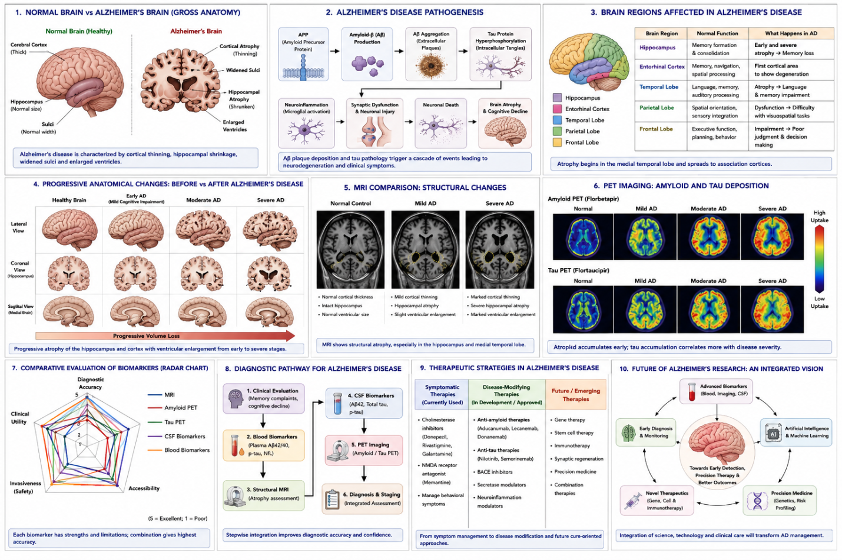
- Introduction
Alzheimer's disease (AD) is the most common cause of dementia worldwide and is characterized by progressive cognitive decline, memory impairment, and neuronal degeneration. As global life expectancy increases, the prevalence of AD continues to rise, creating significant medical, social, and economic challenges.
One of the greatest challenges in Alzheimer's disease is that pathological changes begin years before clinical symptoms become apparent. Therefore, identifying reliable biomarkers capable of detecting the disease during its early stages has become a major focus of neuroscience research.
Several biomarkers—including cerebrospinal fluid biomarkers, blood biomarkers, magnetic resonance imaging (MRI), and positron emission tomography (PET)—have been developed. However, each differs in diagnostic performance, invasiveness, accessibility, and clinical utility.
This project compares these biomarkers to evaluate their potential for early diagnosis of Alzheimer's disease.

2. Aim
The aim of this project is to compare currently available biomarkers for Alzheimer's disease and evaluate their usefulness for early diagnosis based on published scientific literatur

3. Objective
- Review Alzheimer's disease pathology.
- Compare major diagnostic biomarkers.
- Evaluate their advantages and limitations.
- Review emerging therapeutic approaches.
- Identify future research directions.

4. Research Question
Which currently available biomarker shows the greatest potential for the early diagnosis of Alzheimer's disease?
2. Methodology
2.1 Study Design
This project was designed as an independent literature-based comparative analysis. Rather than conducting laboratory experiments or collecting original clinical data, the study critically reviewed and compared published scientific evidence on biomarkers used for the early diagnosis of Alzheimer's disease. A comparative approach was chosen to evaluate the strengths and limitations of different diagnostic strategies based on predefined criteria.
2.2 Literature Search Strategy
Scientific literature was searched using reputable academic databases, including PubMed and Google Scholar. The search focused primarily on peer-reviewed review articles, systematic reviews, clinical guidelines, and high-impact research papers published within the last 5–10 years to ensure that the information reflected current advances in Alzheimer's disease research.
2.3 Inclusion Criteria
The following literature was included:
- Peer-reviewed scientific articles.
- English-language publications.
- Studies focusing on Alzheimer's disease.
- Articles discussing biomarkers for early diagnosis.
- Recent review articles and systematic reviews.
- Publications from approximately the last decade (unless an older landmark paper was necessary for background).
2.4 Exclusion Criteria
The following were excluded:
- Non-peer-reviewed articles.
- Opinion pieces without scientific evidence.
- Studies focused primarily on other forms of dementia.
- Duplicate publications.
- Articles with insufficient methodological information.
2.5 Comparative Evaluation Criteria
To compare the biomarkers objectively, five criteria were used:
Evaluation Criterion Purpose
- Diagnostic Accuracy Ability to correctly identify Alzheimer's disease
- Invasiveness Degree of patient discomfort or procedural risk
- Accessibility Availability in routine clinical practice
- Cost Relative affordability of the diagnostic method
- Clinical Applicability Potential usefulness for early diagnosis

  - Biomarkers Included in the Comparison
The following biomarkers were selected for evaluation:
- Structural MRI
- Amyloid PET imaging
- Tau PET imaging
- Cerebrospinal fluid (CSF) biomarkers
- Blood-based biomarkers (particularly phosphorylated tau proteins)
These biomarkers were chosen because they represent the most widely investigated approaches for the early detection of Alzheimer's disease.
Research Question
↓
Literature Search
↓
Paper Selection
↓
Biomarker Comparison
↓
Critical Evaluation
↓
Conclusion
- Overview of Alzheimer's Disease
3.1 Introduction
Alzheimer's disease (AD) is a progressive neurodegenerative disorder and the most common cause of dementia, accounting for approximately 60–70% of dementia cases worldwide. It is characterized by gradual deterioration of memory, cognitive function, language, reasoning, and behavior, ultimately affecting an individual's ability to perform daily activities. The disease primarily affects older adults, although early-onset forms can occur before the age of 65 due to genetic mutations.
Alzheimer's disease develops over many years before clinical symptoms become apparent. During this preclinical phase, pathological changes occur silently within the brain, including the accumulation of amyloid-beta plaques and hyperphosphorylated tau protein. These pathological processes eventually lead to synaptic dysfunction, neuronal loss, and progressive brain atrophy. Because irreversible neuronal damage has often already occurred by the time symptoms appear, early diagnosis has become a major focus of neuroscience research.

3.2 Epidemiology
Alzheimer's disease represents a significant global public health challenge.
- It is the leading cause of dementia worldwide.
- The prevalence increases markedly with advancing age.
- As life expectancy rises, the number of individuals affected is expected to increase substantially over the coming decades.
- The disease places considerable emotional, social, and economic burdens on patients, caregivers, and healthcare systems.

3.3 Risk Factors

The development of Alzheimer's disease is influenced by both genetic and environmental factors.

Non-modifiable risk factors
- Increasing age
- Family history
- Genetics (e.g., APOE ε4 allele)
- Female sex

Modifiable risk factors
- Hypertension
- Diabetes mellitus
- Obesity
- Physical inactivity
- Smoking
- Poor sleep quality
- Cardiovascular disease
- Social isolation

3.4 Clinical Features
The symptoms of Alzheimer's disease progress gradually.

Early Stage
- Mild memory loss
- Difficulty learning new information
- Misplacing objects
- Mild language problems

Moderate Stage
- Confusion
- Personality changes
- Difficulty recognizing familiar people
- Impaired reasoning

Late Stage
- Severe cognitive decline
- Loss of communication ability
- Difficulty swallowing
- Complete dependence on caregivers

3.5 Importance of Early Diagnosis
One of the greatest challenges in Alzheimer's disease is that pathological changes begin many years before clinical symptoms become evident. Consequently, there is a growing emphasis on identifying reliable biomarkers capable of detecting the disease during its earliest stages. Early diagnosis may facilitate timely intervention, improve patient management, support clinical trial recruitment, and potentially enhance the effectiveness of disease-modifying therapies as they become available
Normal Brain
↓
Preclinical AD
↓
Mild Cognitive Impairment (MCI)
↓
Early Alzheimer's Disease
↓
Moderate AD
↓
Advanced AD

4. Molecular Mechanisms Underlying Alzheimer's Disease

4.1 Introduction
Alzheimer's disease is characterized by a series of interconnected molecular and cellular changes that progressively impair neuronal function and ultimately lead to brain atrophy. Although the exact cause remains incompletely understood, current evidence suggests that the disease results from the interaction of abnormal protein accumulation, neuroinflammation, oxidative stress, vascular changes, and genetic susceptibility. Understanding these mechanisms is essential because many diagnostic biomarkers directly reflect these pathological processes.

4.2 Amyloid-beta (Aβ) Pathology
The amyloid cascade hypothesis proposes that abnormal accumulation of amyloid-beta (Aβ) peptides is one of the earliest pathological events in Alzheimer's disease. Aβ is produced when the amyloid precursor protein (APP) is cleaved by β-secretase and γ-secretase enzymes. Under pathological conditions, Aβ peptides aggregate to form extracellular amyloid plaques.
These plaques disrupt communication between neurons, impair synaptic function, activate inflammatory responses, and contribute to neuronal injury. Because amyloid deposition begins many years before clinical symptoms appear, amyloid imaging and cerebrospinal fluid (CSF) Aβ42 measurements have become important biomarkers for early disease detection.

4.3 Tau Pathology
Tau is a microtubule-associated protein responsible for maintaining neuronal structure and facilitating intracellular transport. In Alzheimer's disease, tau becomes abnormally hyperphosphorylated, causing it to detach from microtubules and aggregate into intracellular neurofibrillary tangles.
The accumulation of tau tangles disrupts neuronal transport, impairs synaptic communication, and eventually leads to neuronal death. Compared with amyloid pathology, tau pathology correlates more closely with cognitive decline, making tau biomarkers valuable indicators of disease severity and progression.
4.4 Neuroinflammation
Chronic neuroinflammation plays a significant role in the progression of Alzheimer's disease. Activated microglia and astrocytes respond to amyloid plaques by releasing inflammatory cytokines and reactive oxygen species. While this response initially aims to clear abnormal protein deposits, prolonged activation contributes to neuronal damage and accelerates disease progression.
Growing evidence suggests that neuroinflammation is not merely a consequence of Alzheimer's disease but an active contributor to its pathology, making inflammatory pathways potential therapeutic targets.

4.5 Synaptic Dysfunction and Neuronal Loss
The combined effects of amyloid accumulation, tau pathology, and chronic inflammation result in progressive synaptic dysfunction and neuronal degeneration. Synaptic loss is strongly associated with memory impairment and cognitive decline, while widespread neuronal death leads to brain atrophy, particularly in the hippocampus and cerebral cortex.
This progressive neurodegeneration explains the structural changes observed using MRI and forms the basis for several imaging biomarkers used in Alzheimer's disease diagnosis.
Normal APP
│
▼
Abnormal APP Cleavage
│
▼
Amyloid-beta Accumulation
│
▼
Amyloid Plaques
│
▼
Microglial Activation
│
▼
Neuroinflammation
│
▼
Tau Hyperphosphorylation
│
▼
Neurofibrillary Tangles
│
▼
Synaptic Dysfunction
│
▼
Neuronal Death
│
▼
Memory Loss & Cognitive Decline

5. Disease Progression and Biomarkers in Alzheimer's Disease

5.1 Why Early Diagnosis Matters
Alzheimer's disease is a slowly progressive disorder in which pathological changes begin many years before clinical symptoms become evident. During this preclinical stage, individuals appear cognitively normal despite ongoing accumulation of amyloid-beta plaques and tau pathology. As neuronal damage progresses, patients may develop Mild Cognitive Impairment (MCI), which represents an intermediate stage between normal ageing and dementia. Eventually, significant neuronal loss results in clinically diagnosed Alzheimer's disease.
Because irreversible neuronal damage has often occurred by the time dementia is diagnosed, identifying reliable biomarkers capable of detecting pathological changes during the preclinical and MCI stages has become a major objective of Alzheimer's disease research.

5.2 Progression of Alzheimer's Disease

Preclinical Alzheimer's Disease
- No noticeable symptoms.
- Amyloid-beta begins accumulating.
- Tau pathology gradually develops.
- Brain changes can already be detected using advanced biomarkers.

Mild Cognitive Impairment (MCI)
- Mild memory impairment.
- Daily activities are mostly preserved.
- Biomarkers become increasingly abnormal.
- Some individuals progress to Alzheimer's dementia, while others do not.

Alzheimer's Dementia
- Progressive cognitive decline.
- Memory impairment.
- Language difficulties.
- Executive dysfunction.
- Significant neuronal loss and brain atrophy.

5.3 Biomarkers Across Disease Progression
Different biomarkers become abnormal at different stages of disease.
Disease Stage | Major Biological Changes | Useful Biomarkers
Preclinical AD | Amyloid accumulation | Amyloid PET, CSF Aβ42, Plasma p-tau
Mild Cognitive Impairment | Tau pathology, synaptic dysfunction | Tau PET, MRI hippocampal atrophy, Plasma p-tau
Alzheimer's Dementia | Extensive neuronal loss | MRI, PET imaging, CSF biomarkers

5.4 Characteristics of an Ideal Biomarker
An effective biomarker should:
- Detect disease before symptoms appear.
- Have high diagnostic accuracy.
- Be minimally invasive.
- Be affordable.
- Be easily accessible.
- Allow monitoring of disease progression.
- Assist clinicians in treatment decisions.
Currently, no single biomarker fulfills all these criteria. Therefore, researchers increasingly recommend combining multiple biomarkers to improve diagnostic accuracy.
Normal Aging
│
▼
Preclinical AD
(Amyloid PET ↑
CSF Aβ ↓
Plasma p-tau ↑)
│
▼
Mild Cognitive Impairment
(Tau PET ↑
MRI changes ↑)
│
▼
Alzheimer's Dementia
(Marked brain atrophy
Severe cognitive decline)

Figure . Timeline illustrating the progression of Alzheimer's disease and the appearance of major diagnostic biomarkers during different stages of disease development.

6. Comparative Evaluation of Major Biomarkers for Early Alzheimer's Disease Diagnosis

6.1 Introduction
The accurate diagnosis of Alzheimer's disease during its early stages remains one of the greatest challenges in clinical neuroscience. Numerous biomarkers have been developed to detect pathological changes before significant cognitive decline occurs. However, each biomarker differs in its diagnostic performance, invasiveness, cost, accessibility, and clinical applicability. Therefore, selecting the most appropriate biomarker requires balancing diagnostic accuracy with practical considerations.
This section compares the major biomarkers currently used in Alzheimer's disease diagnosis using five standardized evaluation criteria.

6.2 Evaluation Criteria
The biomarkers were evaluated based on:
- Diagnostic Accuracy
- Invasiveness
- Accessibility
- Cost
- Clinical Applicability
These criteria were selected because they directly influence the usefulness of biomarkers in routine clinical practice.

Table 1. Comparative Evaluation of Major Alzheimer's Disease Biomarkers
Biomarker | Diagnostic Accuracy | Invasiveness | Accessibility | Cost | Clinical Applicability
MRI Hippocampal Atrophy | Moderate | Non-invasive | High | Moderate | Widely used
Amyloid PET | Very High | Non-invasive | Limited | Very High | Mainly specialized centres
Tau PET | Very High | Non-invasive | Very Limited | Very High | Mostly research settings
CSF Biomarkers | High | Invasive | Moderate | Moderate | Common in specialist centres
Plasma p-tau217 | High (emerging) | Minimally invasive | High | Low | Strong future potential
(Note: "High" or "Very High" are qualitative summaries based on the literature. Avoid inventing exact performance values unless you cite specific studies.)

6.3 Comparative Analysis

MRI
Magnetic Resonance Imaging (MRI) identifies structural brain changes, particularly hippocampal atrophy and cortical thinning. MRI is widely available, non-invasive, and relatively affordable compared with PET imaging. However, structural changes often become more apparent after significant neuronal loss has already occurred, limiting its usefulness as the earliest diagnostic biomarker.

Amyloid PET
Amyloid PET imaging detects amyloid-beta deposition years before clinical symptoms appear, making it one of the earliest available biomarkers. Its major limitations include high cost, limited availability, and exposure to radioactive tracers, which restrict routine clinical use.

Tau PET
Tau PET provides direct visualization of tau pathology and correlates more closely with cognitive decline than amyloid imaging. Nevertheless, limited availability, high cost, and restricted access primarily confine its use to specialized research and tertiary care centres.

CSF Biomarkers
Cerebrospinal fluid analysis measures biomarkers such as Aβ42, total tau, and phosphorylated tau. These biomarkers demonstrate high diagnostic accuracy and are well established in clinical practice. However, lumbar puncture is invasive and may reduce patient acceptance.

Plasma p-tau217
Blood-based phosphorylated tau (p-tau217) has emerged as one of the most promising biomarkers for Alzheimer's disease. Blood collection is minimally invasive, relatively inexpensive, and suitable for large-scale screening. Although ongoing validation is required, recent studies suggest that plasma p-tau217 may offer diagnostic performance approaching that of CSF biomarkers and PET imaging, making it a promising candidate for future routine clinical use.

6.4 Preliminary Interpretation
The comparison suggests that no single biomarker is ideal across all evaluation criteria. Amyloid PET and Tau PET provide excellent diagnostic accuracy but remain expensive and less accessible. MRI is widely available but less sensitive during the earliest stages of disease. CSF biomarkers offer strong diagnostic performance but require invasive sampling. Blood-based biomarkers, particularly plasma p-tau217, appear to provide the most balanced combination of diagnostic accuracy, accessibility, and patient acceptability, making them promising candidates for future early screening

. 6.5 Comparative Decision Matrix

Introduction
To facilitate an objective comparison, the major Alzheimer's disease biomarkers were evaluated using a weighted decision matrix. Five criteria were selected based on their relevance to clinical practice: diagnostic accuracy, accessibility, invasiveness, cost, and clinical applicability.
Because early diagnosis requires balancing scientific performance with practical implementation, each criterion was assigned a weighting according to its relative importance.

Table. Evaluation Criteria and Weighting
Evaluation Criterion | Weight (%) | Reason for Inclusion
Diagnostic Accuracy | 30 | Correct diagnosis is the primary goal.
Clinical Applicability | 25 | Practical value in patient care.
Accessibility | 20 | Availability in healthcare settings.
Invasiveness | 15 | Patient comfort and safety.
Cost | 10 | Important for large-scale implementation.

Scoring Method
Each biomarker was assigned a score from 1 to 5 based on information reported in the scientific literature.
Scoring Scale
Score | Interpretation
1 | Very Poor
2 | Poor
3 | Moderate
4 | Good
5 | Excellent

Table . Comparative Biomarker Evaluation
Biomarker | Accuracy | Clinical Use | Accessibility | Invasiveness | Cost | Overall Observation
MRI | 3 | 5 | 5 | 5 | 3 | Widely used but less sensitive for earliest disease
Amyloid PET | 5 | 4 | 2 | 4 | 1 | Excellent diagnostic performance but expensive
Tau PET | 5 | 3 | 1 | 4 | 1 | Highly informative but limited availability
CSF Biomarkers | 4 | 4 | 3 | 2 | 3 | Strong diagnostic value but invasive
Plasma p-tau217 | 4 | 5 | 5 | 5 | 5 | Promising balance of performance and practicality
Note: These scores are a qualitative synthesis by the author based on the reviewed literature. They are intended to facilitate comparison rather than represent standardized clinical values.

Comparative Interpretation
The decision matrix demonstrates that each biomarker has unique strengths and limitations.
MRI remains highly accessible and non-invasive but is less effective for detecting very early pathological changes. PET imaging provides excellent diagnostic accuracy but is constrained by cost and limited availability. CSF biomarkers have strong diagnostic value but require lumbar puncture, reducing patient acceptability. Blood-based biomarkers, particularly plasma p-tau217, provide an attractive balance between diagnostic performance, accessibility, and patient convenience, making them promising candidates for future routine clinical screening.

While the decision matrix provides a structured comparison of current biomarkers, selecting a single diagnostic test may not always be appropriate. Increasing evidence suggests that combining multiple biomarkers may improve diagnostic accuracy, particularly during the earliest stages of Alzheimer's disease. The following section discusses this integrated diagnostic approach and reviews emerging therapeutic strategies.

7. Integrated Biomarker Approach and Future Diagnostic Strategies

7.1 Why a Single Biomarker is Not Enough
Although individual biomarkers provide valuable information, no single biomarker can accurately diagnose Alzheimer's disease at every stage. Each biomarker reflects a different aspect of the disease process. For example, amyloid PET detects early amyloid-beta deposition, while tau PET reflects neurofibrillary tangle formation. MRI identifies structural brain changes that typically occur later in disease progression, whereas blood-based biomarkers offer a minimally invasive option for large-scale screening.
Therefore, relying on only one biomarker may result in reduced diagnostic accuracy, particularly during the earliest stages of disease.

7.2 Multimodal Biomarker Strategy
Recent research supports combining multiple biomarkers to improve diagnostic confidence.
A possible diagnostic pathway is:

Stage 1: Initial Screening
- Blood-based biomarkers (e.g., plasma p-tau217)
- Cognitive assessment

Stage 2: Clinical Evaluation
- MRI
- Detailed neurological examination

Stage 3: Diagnostic Confirmation
- CSF biomarkers
- Amyloid PET or Tau PET (if available)
This stepwise approach balances diagnostic accuracy with accessibility and cost.

Table . Proposed Integrated Diagnostic Pathway
Clinical Stage | Recommended Test | Purpose
Initial screening | Plasma p-tau217 | Identify individuals at risk
Memory complaints | MRI | Detect structural brain changes
Specialist evaluation | CSF biomarkers | Assess amyloid and tau pathology
Complex cases | Amyloid PET / Tau PET | Confirm diagnosis
(This table is synthesis based on the reviewed literature, not an official clinical guideline.)

7.3 Emerging Diagnostic Technologies
Several emerging technologies may further improve early diagnosis of Alzheimer's disease.

Blood-Based Biomarkers
Recent advances suggest that plasma biomarkers, particularly phosphorylated tau proteins, may enable inexpensive and minimally invasive screening.

Artificial Intelligence
Machine learning algorithms are increasingly being developed to analyze MRI, PET, and biomarker data. These tools may assist clinicians by improving diagnostic accuracy and identifying subtle disease patterns that are difficult to detect through conventional analysis.

Digital Biomarkers
Smartphones, wearable devices, and cognitive assessment applications are being investigated as potential tools for monitoring cognitive decline in real-world settings.

7.4 Author's Comparative Evaluation
Based on the reviewed literature, blood-based biomarkers—especially plasma p-tau217—appear to offer the most promising balance between diagnostic performance, patient comfort, accessibility, and cost. However, they should not currently replace established diagnostic techniques. Instead, a multimodal diagnostic strategy combining blood biomarkers with neuroimaging and cerebrospinal fluid analysis is likely to provide the most accurate approach for early Alzheimer's disease diagnosis.

Patient with Memory Concerns
│
▼
Blood Biomarker Test
│
▼
MRI Examination
│
▼
CSF Biomarkers
│
▼
PET Imaging (if required)
│
▼
Final Clinical Diagnosis
Figure . Proposed multimodal diagnostic pathway for the early evaluation of Alzheimer's disease based on evidence reviewed in this project. (Created by the author.)

While accurate diagnosis is essential, effective patient care also depends on therapeutic interventions capable of slowing disease progression. The following section reviews currently available treatments and emerging therapeutic strategies for Alzheimer's disease.

8. Comparative Evaluation of Current and Emerging Therapeutic Strategies for Alzheimer's Disease

8.1 Introduction
Despite decades of research, Alzheimer's disease remains incurable. Current therapeutic approaches primarily focus on symptom management or slowing disease progression rather than reversing neuronal damage. Recent advances in disease-modifying therapies have renewed interest in targeting the underlying pathological mechanisms of Alzheimer's disease. This section compares the major therapeutic strategies based on their mechanism of action, clinical benefits, limitations, stage of use, and future potential.

8.2 Evaluation Criteria
To enable a structured comparison, therapies were evaluated using the following criteria:
- Mechanism of Action
- Clinical Benefit
- Limitations
- Appropriate Stage of Disease
- Future Potential

Table . Comparative Evaluation of Alzheimer's Disease Therapies
Therapy | Mechanism of Action | Clinical Benefit | Limitations | Best Stage of Use | Future Potential
Cholinesterase Inhibitors | Increase acetylcholine levels | Improves cognition temporarily | Does not stop disease progression | Mild–Moderate AD | Moderate
NMDA Receptor Antagonists | Reduces glutamate-mediated excitotoxicity | Improves symptoms in moderate disease | Symptomatic only | Moderate–Severe AD | Moderate
Anti-Amyloid Monoclonal Antibodies | Remove amyloid-beta plaques | May slow disease progression in selected patients | High cost, monitoring required, limited eligibility | Early AD | High
Lifestyle Interventions | Exercise, diet, cognitive engagement | Supports brain health and quality of life | Limited as a standalone treatment | All stages | Moderate
Gene and Cell-Based Therapies | Target disease mechanisms at the molecular level | Experimental | Not yet routine clinical practice | Future research | Very High

8.3 Comparative Analysis

Cholinesterase Inhibitors
Drugs such as donepezil, rivastigmine, and galantamine increase acetylcholine availability by inhibiting acetylcholinesterase. These medications temporarily improve memory and cognitive function but do not prevent neurodegeneration. Their clinical benefit is therefore mainly symptomatic.

NMDA Receptor Antagonists
Memantine acts by regulating glutamate activity and reducing excitotoxic neuronal damage. It is generally prescribed during moderate to severe Alzheimer's disease and may improve daily functioning. However, like cholinesterase inhibitors, it does not modify the underlying disease process.

Anti-Amyloid Monoclonal Antibodies
Recently developed monoclonal antibodies target amyloid-beta plaques and represent one of the first disease-modifying approaches for Alzheimer's disease. Clinical studies suggest these therapies may slow cognitive decline in carefully selected patients with early disease. However, treatment requires careful monitoring due to potential adverse effects, and long-term benefits continue to be evaluated.

Lifestyle Interventions
Regular physical activity, cardiovascular risk reduction, healthy dietary patterns, cognitive stimulation, and adequate sleep may contribute to maintaining brain health and potentially reducing the risk of cognitive decline. Although these interventions cannot cure Alzheimer's disease, they form an important component of comprehensive patient care.

Gene and Cell-Based Therapies
Emerging therapeutic approaches, including gene editing, stem-cell research, and RNA-based therapies, aim to modify the underlying molecular mechanisms responsible for neurodegeneration. Although these strategies remain largely experimental, they represent promising areas for future translational neuroscience research.

8.4 Comparative Interpretation
The comparison demonstrates that current symptomatic therapies remain valuable for improving patient quality of life but have limited impact on disease progression. Disease-modifying therapies represent an important advance but continue to face challenges related to cost, accessibility, patient selection, and long-term safety. Future therapeutic success is likely to depend on combining early diagnosis with targeted interventions before extensive neuronal loss occurs.

:

Comparison of symptomatic and disease-modifying therapeutic strategies for Alzheimer's disease.

9. Critical Discussion

9.1 Overview
The comparative evaluation presented in this project demonstrates that significant progress has been made in the development of biomarkers and therapeutic strategies for Alzheimer's disease. Nevertheless, important scientific and clinical challenges remain before early diagnosis and disease-modifying treatment can become routine clinical practice. The findings of this review indicate that no single biomarker or therapeutic approach currently fulfills all the requirements for effective diagnosis and management of Alzheimer's disease.

9.2 Which Biomarker Appears Most Promising?
Based on the reviewed literature, blood-based phosphorylated tau (plasma p-tau217) appears to represent one of the most promising biomarkers for future clinical implementation. Compared with cerebrospinal fluid biomarkers and PET imaging, blood-based testing offers several practical advantages, including lower cost, minimal invasiveness, easier sample collection, and greater potential for population-level screening.
However, blood biomarkers should not yet be considered a complete replacement for established diagnostic techniques. Additional multicenter validation studies and standardized laboratory protocols are required before they can be widely adopted in routine clinical practice.

9.3 Why Combination Biomarkers May Be Superior
The evidence reviewed suggests that Alzheimer's disease cannot be adequately characterized using a single biomarker because different biomarkers reflect different pathological processes.
For example:
- Amyloid PET identifies amyloid deposition.
- Tau PET reflects neurofibrillary pathology.
- MRI demonstrates structural neurodegeneration.
- Blood and CSF biomarkers detect biochemical changes associated with disease progression.
Consequently, combining these complementary biomarkers may improve diagnostic accuracy, reduce false-positive and false-negative results, and provide a more comprehensive understanding of disease progression.

9.4 Challenges in Current Clinical Practice
Despite substantial scientific advances, several challenges continue to limit the widespread clinical implementation of Alzheimer's disease biomarkers.
These include:
- High cost of PET imaging.
- Limited availability of advanced neuroimaging facilities.
- Invasive nature of lumbar puncture for CSF collection.
- Variability between laboratories.
- Difficulty distinguishing Alzheimer's disease from other neurodegenerative disorders.
- Limited access to specialist diagnostic centers in many regions.
These challenges highlight the need for more affordable, standardized, and accessible diagnostic methods.

9.5 Personal Critical Evaluation
Based on the evidence reviewed in this project, I believe that the future of Alzheimer's disease diagnosis will depend on integrated diagnostic strategies rather than reliance on a single biomarker. Blood-based biomarkers have the potential to transform early screening because they are less invasive and more accessible than current diagnostic approaches. However, until sufficient clinical validation is available, combining blood biomarkers with neuroimaging and clinical assessment appears to offer the most reliable strategy for early diagnosis. Continued collaboration between neuroscience research, clinical medicine, and biotechnology will be essential to improve patient outcomes.
This is an interpretation of the literature—not a personal opinion without evidence.

Figure . Proposed integrated diagnostic framework for future Alzheimer's disease diagnosis.

10. Future Research Directions

10.1 Introduction
Although significant advances have been made in understanding Alzheimer's disease, important scientific and clinical challenges remain. Current diagnostic biomarkers and therapeutic strategies have improved early detection and disease management; however, limitations in accessibility, cost, diagnostic accuracy, and treatment effectiveness continue to hinder widespread clinical implementation. Future neuroscience research should focus on developing more accurate, affordable, and personalized approaches for the diagnosis and treatment of Alzheimer's disease.

10.2 Future Development of Blood-Based Biomarkers
Blood-based biomarkers represent one of the most promising areas of Alzheimer's disease research. Biomarkers such as plasma phosphorylated tau (p-tau217), p-tau181, and neurofilament light chain (NfL) have demonstrated encouraging diagnostic performance in recent studies.
Future research should focus on:
- Standardizing laboratory testing procedures.
- Validating biomarker performance across diverse populations.
- Establishing universal diagnostic cut-off values.
- Integrating blood biomarkers into routine clinical practice.
If successfully implemented, blood-based biomarkers could improve early diagnosis while reducing dependence on more invasive or expensive diagnostic procedures.

10.3 Artificial Intelligence in Alzheimer's Disease Diagnosis
Artificial intelligence (AI) and machine learning have emerged as powerful tools for analyzing large and complex clinical datasets.
Potential applications include:
- Automated MRI image analysis.
- Prediction of disease progression.
- Integration of imaging, genetic, and biomarker data.
- Personalized risk prediction.
AI has the potential to support clinicians by improving diagnostic accuracy and identifying subtle disease-related changes that may not be readily apparent through conventional analysis. However, further validation, transparency, and ethical oversight are required before widespread clinical adoption.

10.4 Precision Medicine and Personalized Treatment
Increasing evidence suggests that Alzheimer's disease is biologically heterogeneous, meaning that disease mechanisms may vary between individuals.
Future therapeutic strategies may include:
- Personalized biomarker-guided treatment.
- Genetic risk assessment.
- Individualized therapeutic selection.
- Precision medicine approaches combining biomarkers with clinical characteristics.
These approaches may improve treatment effectiveness while minimizing unnecessary interventions.

10.5 Research Gaps Identified
Based on this literature review, several important gaps remain:
- Limited long-term validation of emerging blood biomarkers.
- High cost and restricted accessibility of PET imaging.
- Lack of standardized biomarker interpretation across healthcare settings.
- Limited availability of disease-modifying therapies.
- Need for improved understanding of disease mechanisms before symptom onset.
Addressing these gaps may improve both early diagnosis and long-term clinical outcomes.

10.6 Final Perspective
The future of Alzheimer's disease research is likely to involve a multidisciplinary approach integrating neuroscience, molecular biology, neuroimaging, artificial intelligence, and precision medicine. Continued collaboration among researchers, clinicians, and biotechnology industries will be essential to translate scientific discoveries into practical clinical applications. Advances in early diagnosis and targeted therapies may ultimately improve patient outcomes and reduce the global burden of Alzheimer's disease.

Figure Key future research directions in Alzheimer's disease, highlighting the integration of biomarkers, artificial intelligence, precision medicine, and disease-modifying therapies.

11. Conclusion

11.1 Summary of Findings
This project aimed to comparatively evaluate current biomarkers for the early diagnosis of Alzheimer's disease and review emerging therapeutic strategies based on published scientific literature. The findings demonstrate that significant advances have been made in understanding the molecular mechanisms of Alzheimer's disease, leading to the development of increasingly sensitive diagnostic biomarkers and novel disease-modifying therapies.
The comparative evaluation showed that each biomarker possesses distinct advantages and limitations. Neuroimaging techniques such as MRI and PET provide valuable structural and molecular information but remain limited by cost, accessibility, or sensitivity during the earliest stages of disease. Cerebrospinal fluid biomarkers offer excellent diagnostic performance but require invasive sample collection. In contrast, blood-based biomarkers, particularly plasma phosphorylated tau (p-tau217), have emerged as promising tools due to their combination of diagnostic accuracy, minimal invasiveness, and potential suitability for routine clinical screening.

11.2 Answer to the Research Question
Research Question:
"Which currently available biomarker demonstrates the greatest potential for the early diagnosis of Alzheimer's disease when evaluated for diagnostic accuracy, invasiveness, accessibility, and clinical applicability?"
Answer:
Based on the comparative evaluation conducted in this project, plasma phosphorylated tau (p-tau217) appears to offer the most balanced combination of diagnostic performance, accessibility, patient comfort, and future clinical applicability. However, current evidence also suggests that no single biomarker is sufficient for comprehensive diagnosis. Instead, combining blood biomarkers with neuroimaging and clinical assessment is likely to provide the most reliable approach for the early detection of Alzheimer's disease.

11.3 Key Learning Outcomes
This project enhanced understanding of:
- The molecular pathology of Alzheimer's disease.
- The strengths and limitations of current diagnostic biomarkers.
- The importance of comparative evaluation in selecting diagnostic tools.
- The role of translational neuroscience in bridging laboratory discoveries with clinical applications.
- The need for multidisciplinary approaches integrating neuroscience, biotechnology, neuroimaging, and computational methods to improve patient care.

11.4 Final Remarks
Early diagnosis remains one of the greatest challenges in Alzheimer's disease research and clinical practice. Continued advances in biomarker discovery, artificial intelligence, precision medicine, and disease-modifying therapies have the potential to transform the diagnosis and management of neurodegenerative disorders. Although substantial challenges remain, ongoing interdisciplinary research offers promising opportunities to improve patient outcomes and reduce the global burden of Alzheimer's disease.

:
Research Question
│
▼
Literature Review
│
▼
Biomarker Comparison
│
▼
Comparative Evaluation
│
▼
Integrated Diagnosis
│
▼
Future Research
Figure . Overall workflow and key findings of the present literature-based comparative evaluation of Alzheimer's disease biomarkers.

This project is based on published scientific literature and does not include original laboratory experiments or clinical data. The comparative evaluation reflects the evidence available at the time of writing and may evolve as new biomarkers and therapies are validated. Additionally, the qualitative scoring framework was developed by the author to facilitate structured comparison and should not be interpreted as a standardized clinical assessment tool. References
REFERNCES
- Jack C. de la Torre. (2023). Alzheimer disease: Pathogenesis, diagnosis, and management. Journal of Alzheimer's Disease.
- Clifford R. Jack Jr., et al. (2018). NIA-AA Research Framework: Toward a biological definition of Alzheimer's disease. Alzheimer's & Dementia, 14(4), 535–562.
- Oskar Hansson. (2021). Biomarkers for neurodegenerative diseases. Nature Medicine.
- Kaj Blennow, & Henrik Zetterberg. (2018). Biomarkers for Alzheimer's disease: Current status and prospects. Journal of Internal Medicine.
- Henrik Zetterberg, & Kaj Blennow. (2021). Blood biomarkers: Democratizing Alzheimer's diagnostics. Neuron.
- Maria C. Carrillo, et al. (2022). Blood-based biomarkers for Alzheimer's disease: Current state and future perspectives. Alzheimer's & Dementia.
- John Hardy, & David Allsop. (1991). Amyloid deposition as the central event in Alzheimer's disease. Trends in Pharmacological Sciences.
- John Q. Trojanowski, & Virginia M.-Y. Lee. (2005). The role of tau in Alzheimer's disease. Nature Reviews Neuroscience.
- Michael Weiner, et al. (2017). The Alzheimer's Disease Neuroimaging Initiative (ADNI): A review. Alzheimer's & Dementia.
- World Health Organization. (2023). Dementia. (Use the official WHO fact sheet.)
- Alzheimer's Association. (2024). 2024 Alzheimer's Disease Facts and Figures.

Limitations of the Project
This project is an independent literature-based comparative analysis and does not include original laboratory experiments or clinical data. The conclusions presented are derived from published scientific evidence available at the time of writing. The comparative scoring framework was developed solely to facilitate structured evaluation and should not be interpreted as a validated clinical assessment tool. Future research may refine these findings as new biomarkers and therapeutic strategies emerge.

